Task Description:

Setup minikube at your local and explore creating namespaces (Go through official documentation).

Techstacks needs to be used :

- Vbox, WSL
- Docker
- Minikube
- Kubectl
If the Local system has any issues you can use AWS.
- AWS EC2 (t2.medium)
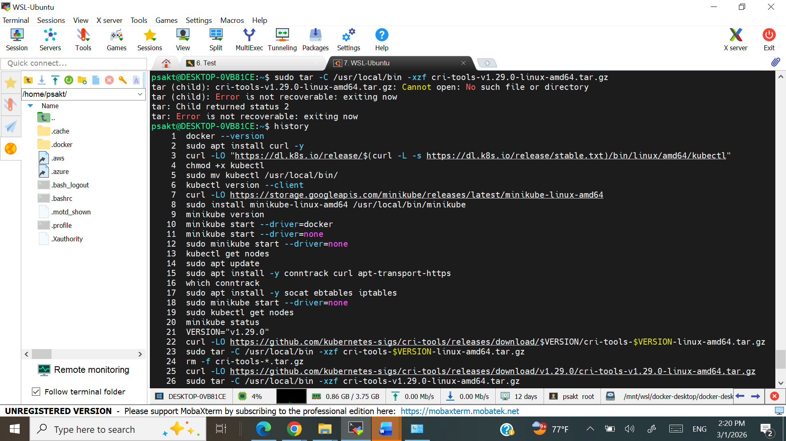


minikube v1.38.1 on Ubuntu 24.04 (amd64)
Using the none driver based on user configuration
Starting control plane node minikube in cluster minikube
Creating Kubernetes cluster ...
Done! kubectl is now configured to use "minikube"

sudo kubectl get nodes
NAME STATUS ROLES AGE VERSION
minikube Ready control-plane 2m v1.35.1

sudo kubectl get namespaces
NAME STATUS AGE
default Active 3m
kube-system Active 3m
kube-public Active 3m
kube-node-lease Active 3m

